AWS Deployment Commands

• EC2 Setup Commands
sudo apt update && sudo apt upgrade -y
sudo apt install python3 python3-pip python3-venv -y
mkdir mycloudproject
cd mycloudproject
nano model.py
nano app.py
nano insurance.csv
python3 model.py
mkdir templates
nano templates/index.html
pip install flask pandas numpy scikit-learn boto3
python3 -m venv venv
source venv/bin/activate
python app.py (run the application)

• Running Application
python app.py

• Security Group Configuration
Port | Purpose
22 | SSH
80 | HTTP
5000 | Flask Add

OUTPUT
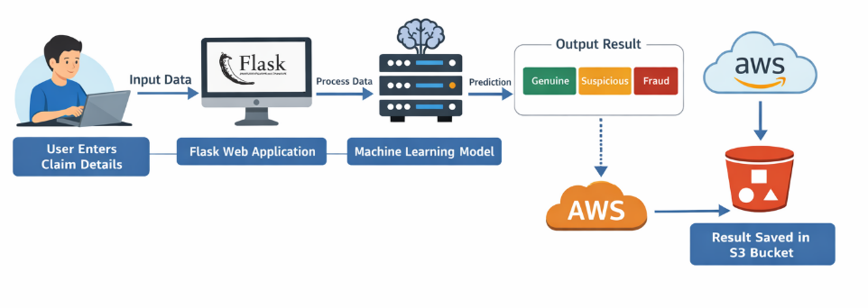
Figure 5.1: Flow diagram

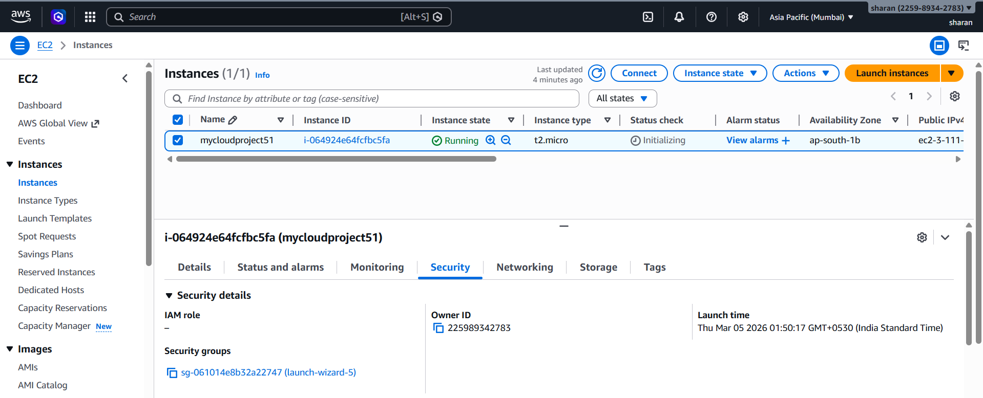
Figure 5.2: AWS EC2 Instance Running (Virtual Machine Hosting the Application)

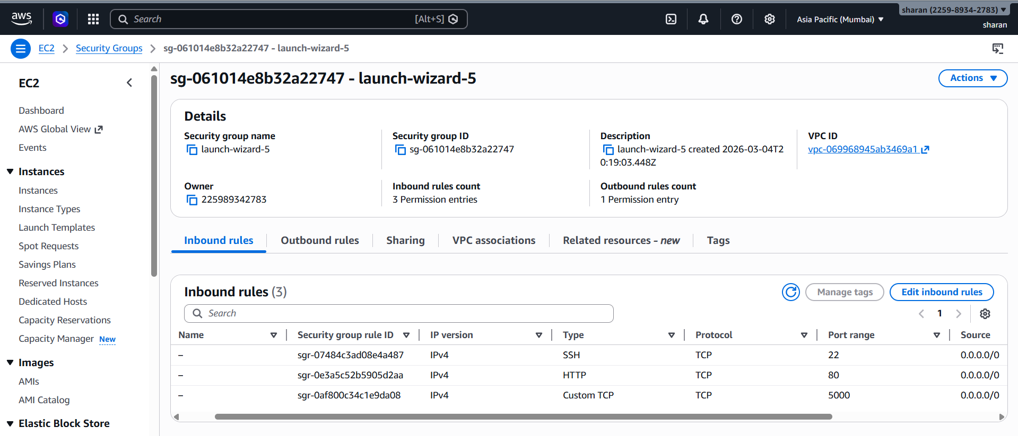
Figure 5.3: AWS Security Group Inbound Rules Configuration
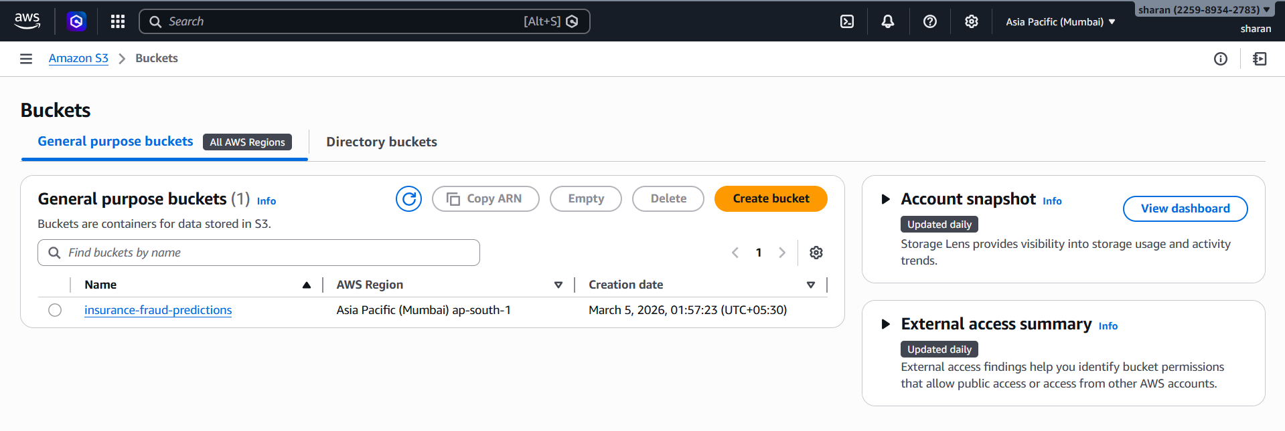
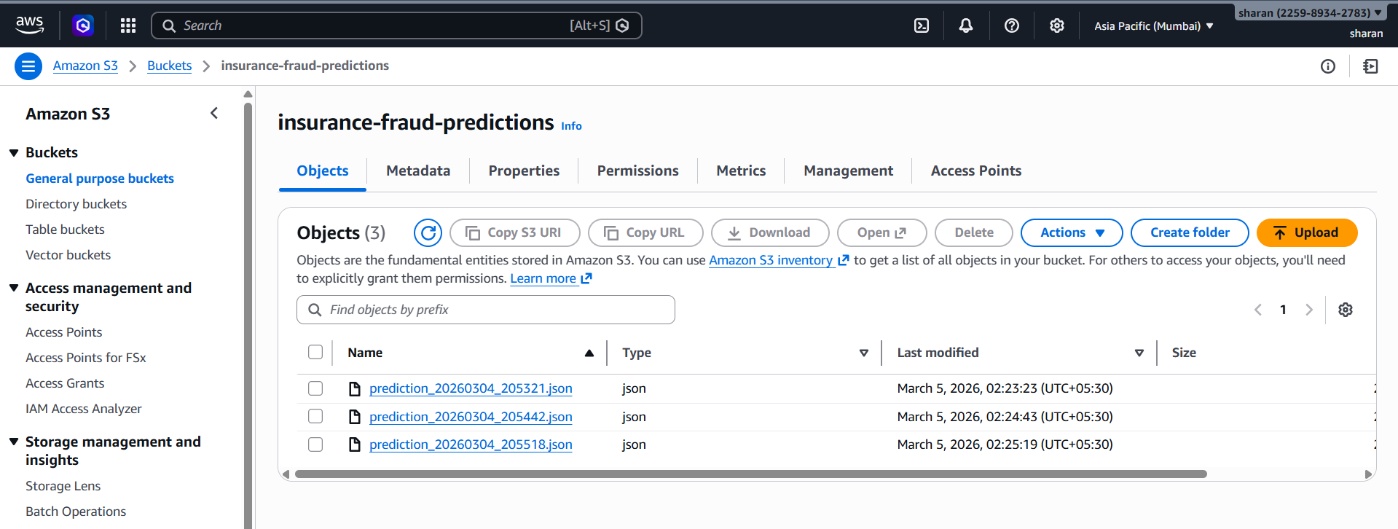
Figure 5.4: Amazon S3 Bucket with Prediction Results

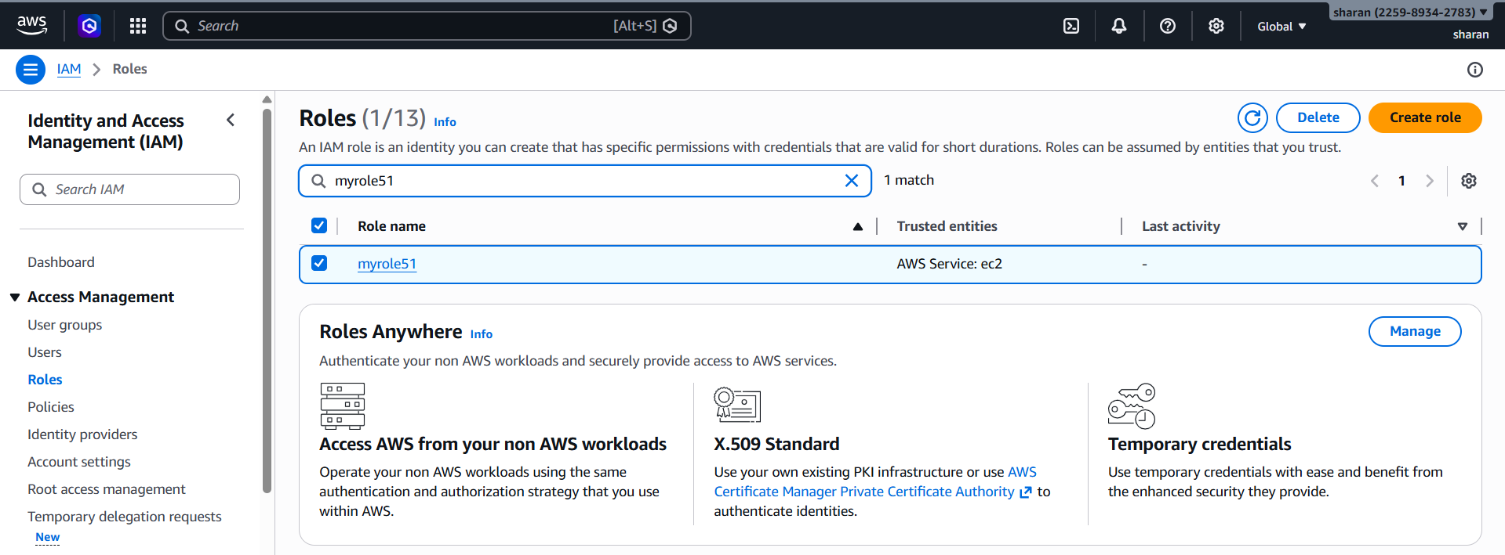
Figure 5.5: IAM Role (myrole51) with permission AmazonS3FullAccess to access S3

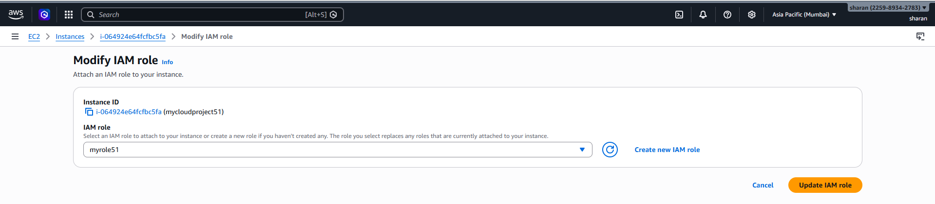
Figure 5.6: Attach the IAM role to EC2 instance

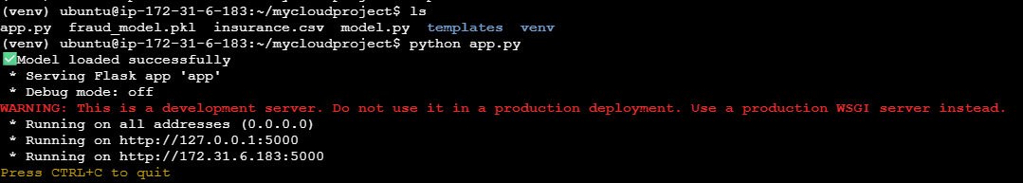
Figure 5.7: Flask Application Running Inside EC2 Virtual Machine

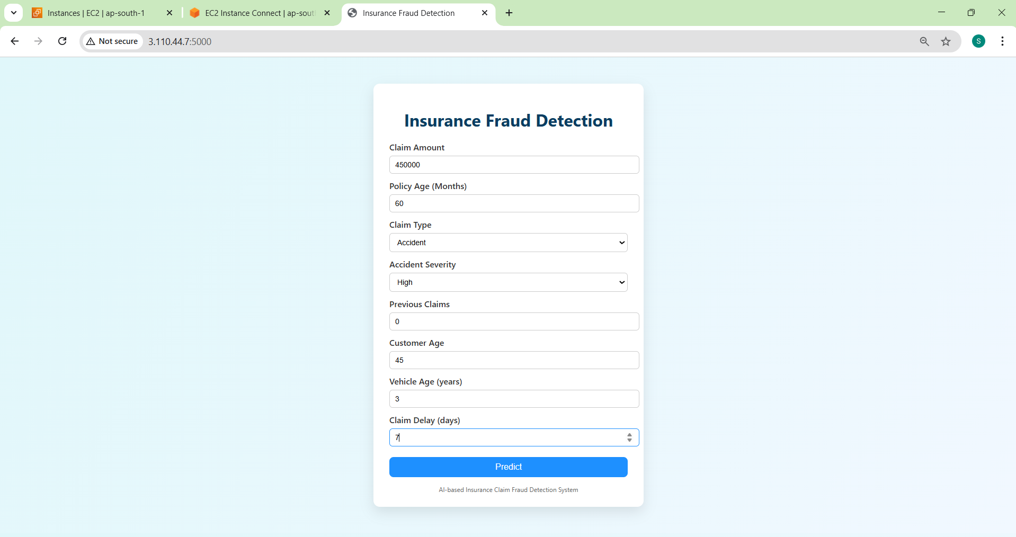
Figure 5.8: Insurance Claim Fraud Detection Application Hosted on AWS EC2

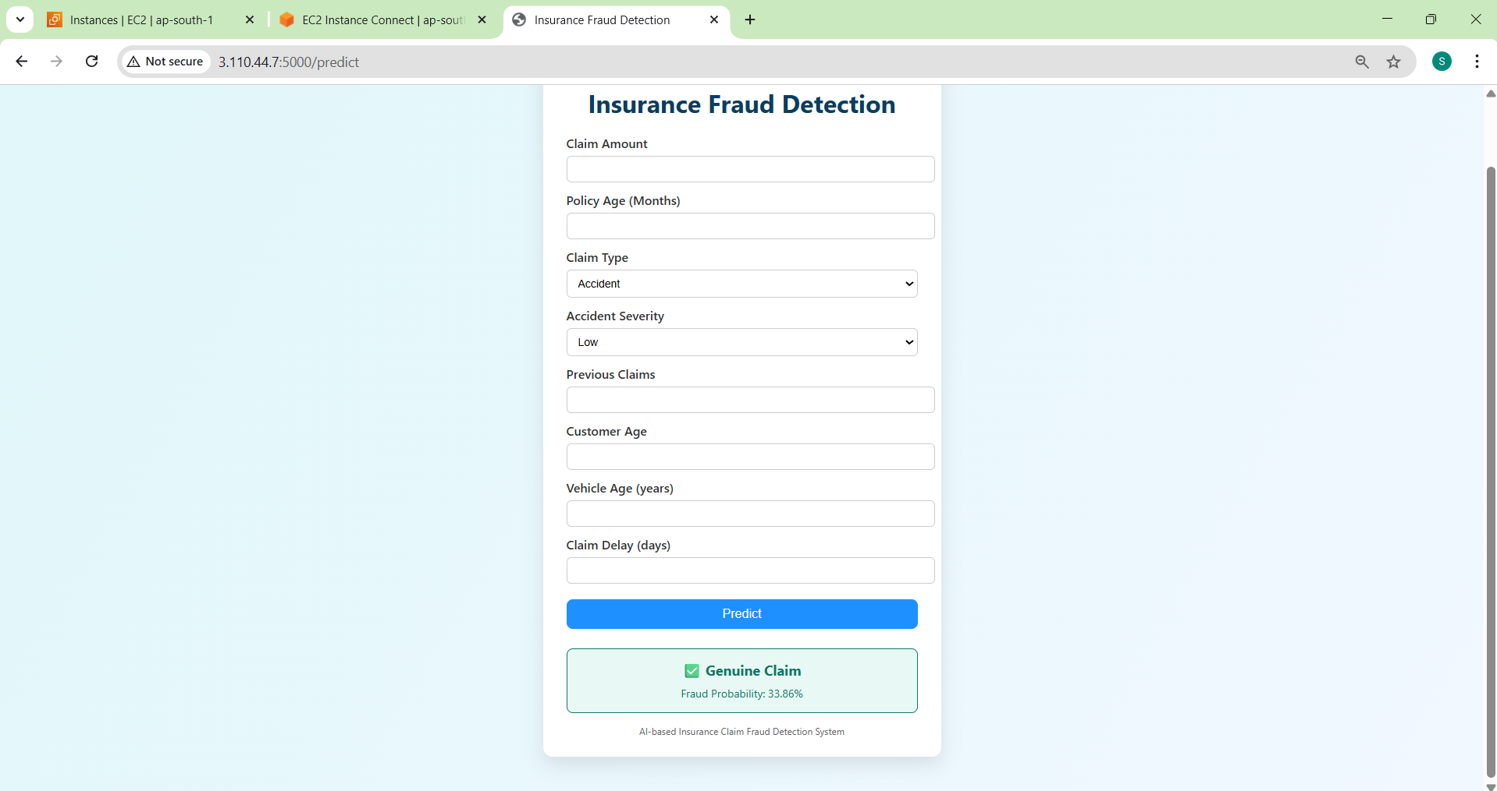
Figure 5.9: Prediction Result with Fraud probability

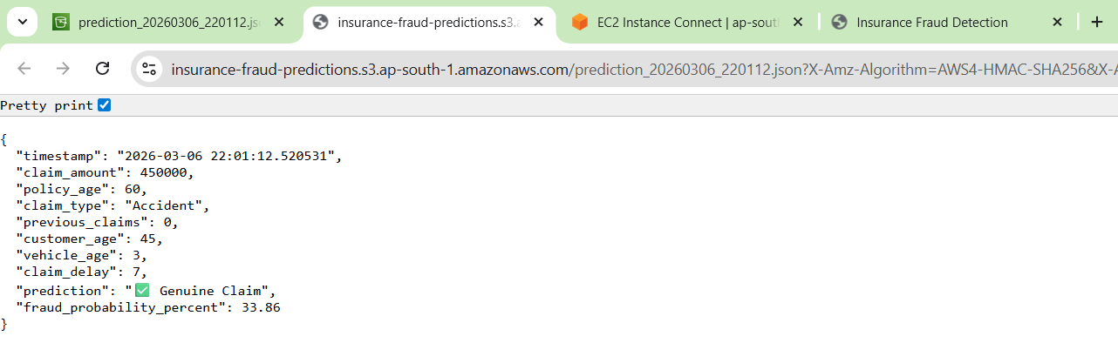
Figure 5.10: Access the Prediction stored in S3

